**Assignment 3**

**CS 455/555**

Maitri Mangal

[mmangal1@binghamton.edu](mailto:mmangal1@binghamton.edu)

Fall 2018

**Purpose:**

To understand and implement different ways to enhance an image given the following concepts:

* RGB to HSI
* Discrete Cosine Transformations (DCT)
  + 8 point
  + 8 point inverse
* Region of Interest
  + Sobel

**To Run:**

On command line type: make (This will make the executable file assign3)

Next type: ./assign3 (All the images presented in this file will then be displayed)

**To Remove Executable File:**

On command line type: make clean

**Notes:**

**Methods to obtaining Images**

Method for Calculating XGradient and YGradient:

Create mask 3x3 that consists of:

-1 -2 -1

0 0 0

1 2 1

Apply matrix to the given image by multiplying according coordinates and summing all

Method for Sobel Operator:

Create a new Image, and initialize all pixels to 0

For each pixel of original image, calculate the horizontal and vertical gradient.

Add these two gradients together to find the total gradient

If total gradient > 255, then total gradient = 255

If total gradient < 0, then total gradient = 0

Replace each pixel in new image with the total gradient

Method for RGB to HSI:

Used following formulas:

Hue: $\cos^{-1}\{\frac{\frac{1}{2}[\left(R-G\right)+(R-B)]}{{[{\left(R-G\right)}^{2}+(R-B)(G-B)]}^{1/2}}\}$

Saturation: 1 – [min(R, G, B)/ I]

Intensity (I): (1/3)(R+G+B)

Method for DCT:

Used formula:



For both a(u) and a(v)



Method for IDCT:

Used formula:



For both a(u) and a(v):



Methods for DCT_DC:

In DCT image, keep first element of each 8x8 matrix, and change rest to 0

Methods for DCT_9:

In DCT image, keep upper left 9 elements of each 8x8 matrix, and change rest to 0

Methods for ROI:

Sobel operator on RGB Image

Results:

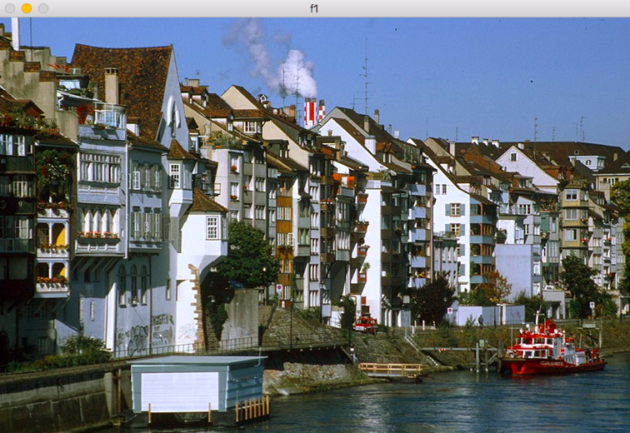Original Image:

HSI Image:

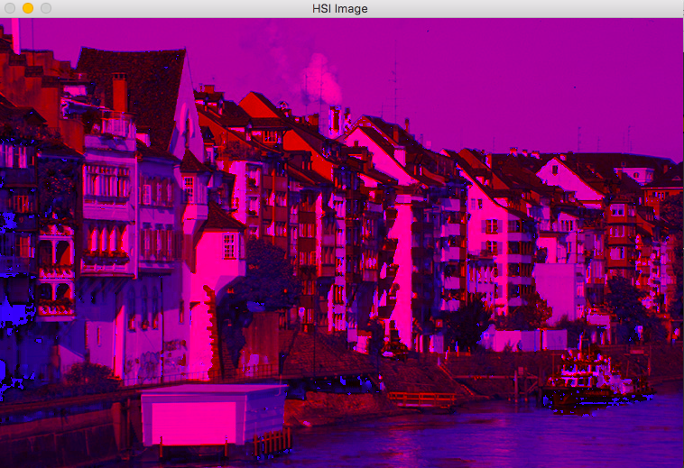

Red Intensity:

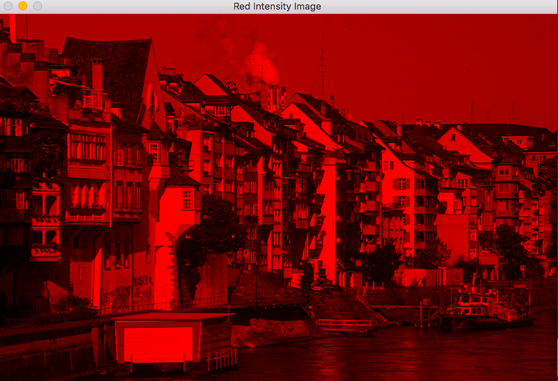

Green Intensity:

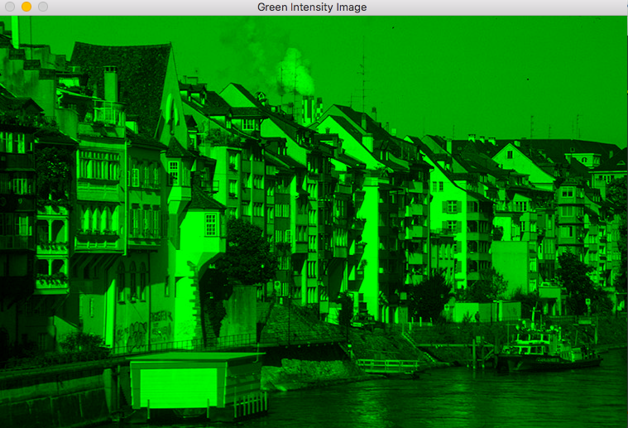

Blue Intensity:

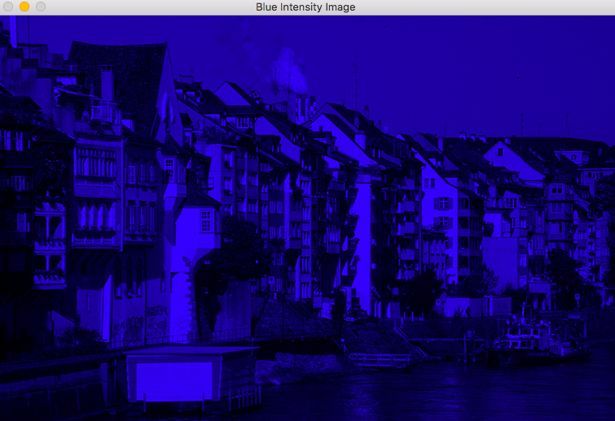

DCT Image:

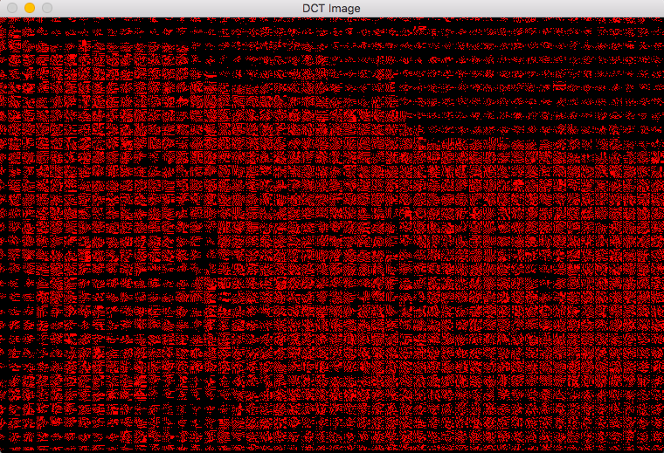

DCT_DC Image:

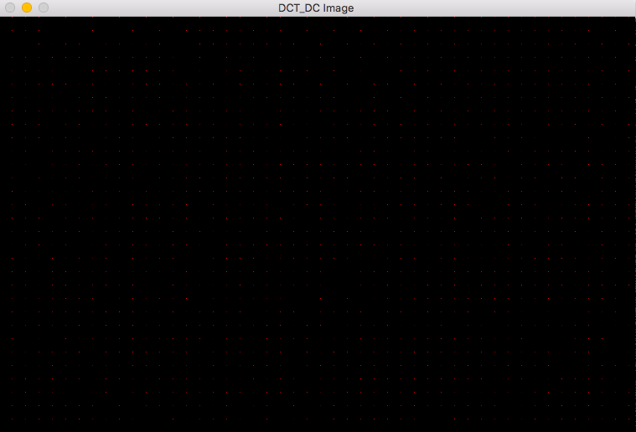

DCT_9 Image:

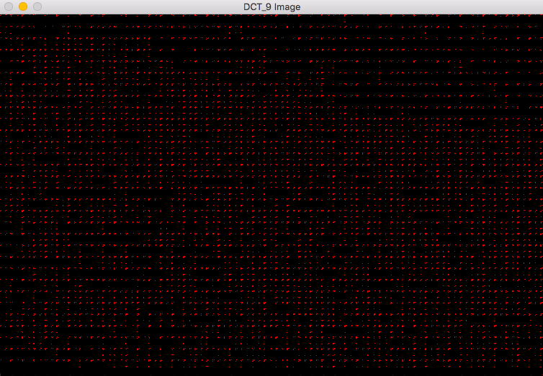

IDCT_DC Image:

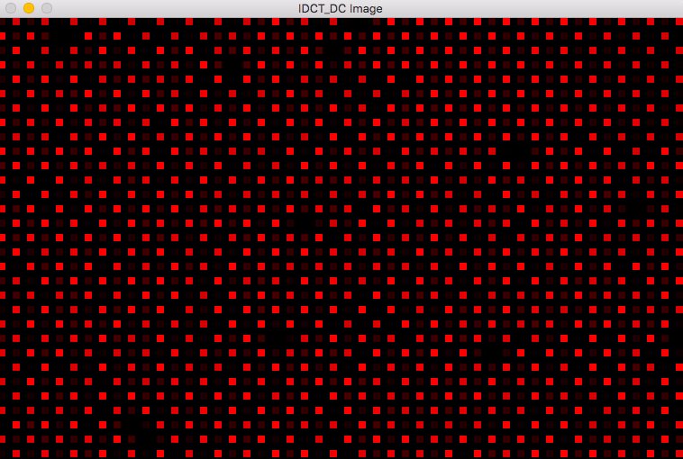

IDCT_9 Image:

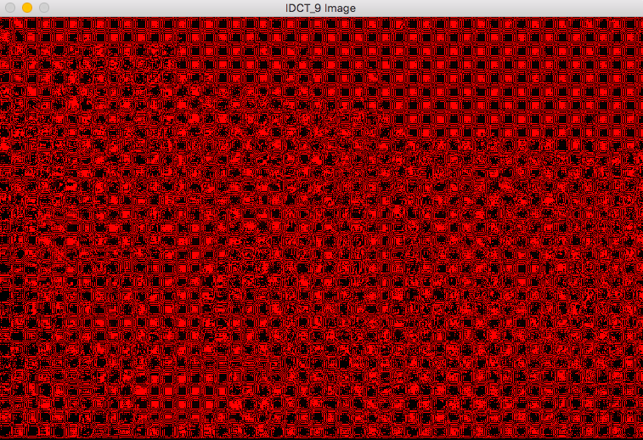

Building ROI Image:

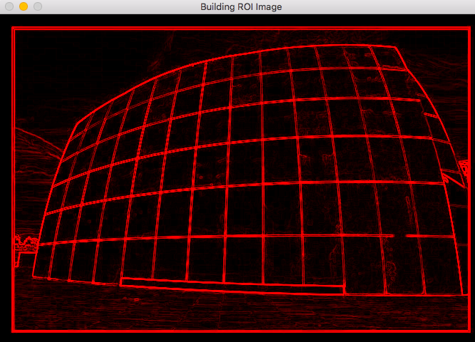

Disk ROI Image:

